DATA STRUCTURES & ALGORITHMS (23CS4111)
Assignment Set 2 - Programming
UNIT-II: Stacks and Queues

3.An expression-processing application receives an arithmetic expression in infix form. Write a C program using a stack to convert it to postfix form while correctly handling parentheses and operator precedence for +, -, *, / and ^. Test the program using an expression containing multiple operators and parentheses.

Source Code:
#include <stdio.h>
#include <ctype.h>
#include <string.h>
#define MAX 100

char stack[MAX];
int top = -1;

void push(char c) {
if (top == MAX - 1) {
printf("Stack overflow\n");
return;
}
stack[++top] = c;
}

char pop() {
if (top == -1)
return '\0';
return stack[top--];
}

char peek() {
return stack[top];
}

int precedence(char c) {
switch (c) {
case '^': return 3;
case '*':
case '/': return 2;
case '+':
case '-': return 1;
}
return 0;
}

int main() {
char infix[MAX], postfix[MAX], ch, t;
int i, k, error, choice;

do {
top = -1;
k = 0;
error = 0;

printf("\nEnter a valid infix expression (no spaces): ");
scanf("%s", infix);

for (i = 0; infix[i] != '\0' && !error; i++) {
ch = infix[i];
if (isalnum(ch)) {
postfix[k++] = ch;
} else if (ch == '(') {
push(ch);
} else if (ch == ')') {
while (top != -1 && peek() != '(')
postfix[k++] = pop();
if (top == -1)
error = 1; /* no matching '(' */
else
pop(); /* discard '(' */
} else if (strchr("+-*/^", ch)) {
while (top != -1 && peek() != '(' &&
(precedence(peek()) > precedence(ch) ||
(precedence(peek()) == precedence(ch) && ch != '^')))
postfix[k++] = pop();
push(ch);
} else {
error = 1; /* invalid character */
}
}

while (top != -1 && !error) {
t = pop();
if (t == '(')
error = 1; /* no matching ')' */
else
postfix[k++] = t;
}
postfix[k] = '\0';

if (error)
printf("Invalid expression (unbalanced parentheses or bad symbol).\n");
else {
printf("Infix : %s\n", infix);
printf("Postfix : %s\n", postfix);
}

printf("Convert another expression? (1 = Yes, 0 = No): ");
scanf("%d", &choice);
} while (choice == 1);

return 0;
}

Output:
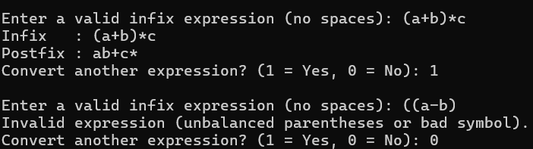

4.A service centre uses a fixed-size request buffer in which released positions must be reused. Write a C program to implement a Circular Queue using an array with insertion, deletion, display, overflow and underflow operations. Demonstrate that positions freed after deletion can be reused for new requests.

Source Code:
#include <stdio.h>
#define SIZE 5

int queue[SIZE];
int front = -1, rear = -1;

int isFull() { return front == (rear + 1) % SIZE; }
int isEmpty() { return front == -1; }

void enqueue(int x) {
if (isFull()) {
printf("Queue OVERFLOW! Cannot insert %d.\n", x);
return;
}
if (isEmpty())
front = 0;
rear = (rear + 1) % SIZE;
queue[rear] = x;
printf("Request %d inserted at position %d.\n", x, rear);
}

void dequeue() {
int x;
if (isEmpty()) {
printf("Queue UNDERFLOW! No request to delete.\n");
return;
}
x = queue[front];
printf("Request %d deleted from position %d.\n", x, front);
if (front == rear)
front = rear = -1;
else
front = (front + 1) % SIZE;
}

void display() {
int i;
if (isEmpty()) {
printf("Queue is empty.\n");
return;
}
printf("Queue contents (front -> rear): ");
i = front;
while (1) {
printf("%d ", queue[i]);
if (i == rear)
break;
i = (i + 1) % SIZE;
}
printf("\nfront = %d, rear = %d\n", front, rear);
}

int main() {
int choice, x;
do {
printf("\n1.Insert 2.Delete 3.Display 4.Exit\nEnter choice: ");
scanf("%d", &choice);
switch (choice) {
case 1:
printf("Enter request number: ");
scanf("%d", &x);
enqueue(x);
break;
case 2:
dequeue();
break;
case 3:
display();
break;
case 4:
printf("Exiting program.\n");
break;
default:
printf("Invalid choice!\n");
}
} while (choice != 4);
return 0;
}

Output:
